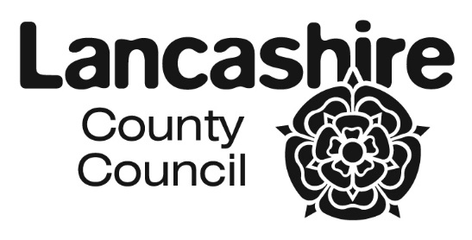
CO-ORDINATED ADMISSION SCHEME FOR
LANCASHIRE SCHOOLS AND ACADEMIES 2021/22
SEPTEMBER 2021 INTAKES

SECONDARY |  | PRIMARY
DATE | ACTION | DATE | ACTION
1 September 2020 | Online application system goes live and requests for paper forms / booklets accepted and considered | 1 September 2020 | Online application system goes live and requests for paper forms / booklets accepted and considered
31 October 2020 | Closing date for applications  (statutory) | 15 January 2021 | Closing date for applications  (statutory)
6 November 2020 | Primary schools / academies to forward any paper applications to Area Pupil Access Teams | 22 January 2021 | Primary schools / academies to forward any paper applications to Area Pupil Access Teams
20 November 2020 | Preferences information exchange with other Local Authorities | 29 January 2021 | Preferences information exchange with other Local Authorities
4 December 2020 | Information to be exchanged with Own Admission Authority Schools | 5 February 2021 | Information to be exchanged with Own Admission Authority Schools
11 December 2020 | Admission authority to confirm intention to exceed PAN with the LA | 12 February 2021 | Admission authority to confirm intention to exceed PAN with the LA
23 December 2020 | Prioritised (ranked) lists back to the Local Authority | 28 February 2021 | No further address changes can be accepted.
15 January 2021 | No further address changes can be accepted. | 19 March 2021 | Prioritised (ranked) lists back to the Local Authority
22 January 2021 | Further exchange of lists with other admission authorities | 26 March 2021 | Further exchange of lists with other admission authorities
12 February 2021 | No changes at all can be made to offer letters after this date | 2 April 2021 | No changes at all can be made to offer letters after this date
26 February 2021 | Issue finalised offer lists to secondary schools / academies | 16 April 2021 | Issue finalised offer lists to primary schools / academies
1 March 2021 | Issue offer letters/emails.  (statutory date is 1st March or the next working day) | 16 April 2021 | Issue offer letters/emails.  (statutory dates)

The closing dates and offer dates are national statutory requirements. The dates of exchanges of information may on occasion vary slightly by agreement to take into account localised issues associated with workload and / or specific situations affecting a school / academy or a group of establishments. Occasionally delays may occur as neighbouring authorities will be working to different timetables.

Where a statutory offer date is on a weekend or public holiday Lancashire's online system will go live on that day allowing online applicants to access their offer. In these circumstances and for paper applications letters will (where workload allows) be issued on the previous working day and are likely to arrive after the online system notifications.

